

*Bargach Fatna, mat 243374,* [*fatna.bargach@studenti.unitn.it*](mailto:fatna.bargach@studenti.unitn.it)

*Bessegato Giulia, mat 245638,* [*giulia.bessegato@studenti.unitn.it*](mailto:giulia.bessegato@studenti.unitn.it)

*Capanni Teresa, mat 249419,* [*teresa.capanni@studenti.unitn.it*](mailto:teresa.capanni@studenti.unitn.it)

*Tomaselli Alessia, mat 249424,* [*alessia.tomaselli@studenti.unitn.it*](mailto:alessia.tomaselli@studenti.unitn.it)

**Does employment make a difference?**

*A quantitative study around Europe about immigrants perceived integration.*

Master in “Sociology and Social Research”

Academic Year 2023/2024

**Abstract**

Europe in the past couple of decades, especially, has been the target of substantial migratory flows, within the continent but also from outside, causing some changes in societies where immigrants settled. Having different cultural, religious and economic backgrounds the issue of integration arose, not only stimulating the interest on the topic of different researchers, but also forcing different governments to take action and propose solutions and policies regarding the integration of this new wave of population settling in their respective countries. The issue concerning integration to society does not just concern the immigrant population, but it has become more relevant towards the latter. Being the aspiration to find an occupation, the main motif of immigration, it is reasonable to analyse if the employment status of immigrants influences their perception of integration in the host country. The relationship between employment and integration can be, also enhanced by other factors such as gender, level of education and the host country immigrated in. The results provided by the analysis of this paper show that, first, employment influences the perception of immigrants of integration, second, females are less integrated through employment compared to their males counterparts, third, level of integration varies depending on the host country an immigrant finds himself, and finally, the more educated the immigrant is the less he feels integrated in the host country.

**Keywords:** Immigrants, Employment, Integration, Labour market, Europe

1. **Introduction**

Integration is a process which is necessary for the functioning of society, that allows the population to live in harmony and it could be realised in many different ways, depending on the country in which you are migrating to.

The aim of this paper is to analyze the relationship between employment and integration, and in particular how the first influences the integration of immigrants in Europe. The target group for this research are immigrants living in a host country. Integration, in the past few decades in Europe, has been an important topic in politics, which is trying to propose policies that make the process of integration easier for immigrants and for host countries.

Other factors such as gender and level of education could affect the relationship between employment and integration: in this paper we consider them not as mediators of the relationship, but rather as covariates, since they are factors that pre-exist the independent variable, that is the employment status.

The research questions that we’ll try to answer in this context are essentially three:

Q1: Considering the immigrant population, does being employed encourage the integration of the latter? (Integration being measured with the perception that the immigrants have of the closeness they feel to the host country)

Q2: Is there a difference between males and females when it comes to the integration? (Always taking under consideration the employment status)

Q3: Does the level of education influence the possibility for migrants to have a job in the host country and consequently be more integrated in the society of the latter, controlling for gender?

1. **Theoretical Framework**

**2.1 Relation between immigrant employment status and immigrant integration**

By the second half of the 20th century, after world war two, European societies transformed into Work societies (Arendt 1958) in which employment status and positions in the labour market determine individual identity, social status and social integration. The main characteristic of a work society is that the social participation of a large majority of the population is based, directly or indirectly, on employment.

It is necessary, however, to take into consideration the fact that when we talk about sociology of work it is important to assess integration possibilities: the ambivalent nature of social integration through employment (Schmidt 2018). In other words, employment integrates people socio-economically and socially, but in doing so assigns them unequal social statuses and social recognition (Grimm, N., Hense, A., & Vogel, B., 2023). Alba and colleagues’s book (2015) provides an empirical analysis of immigrant integration across several immigration nations: it reports five ‘grand narratives’ of cross-national differences in immigrant integration, and one of these is political economy (nature of labour market regulation, education, and welfare state regime).

In Huddleston and colleagues' report (2013) that concerns EU indicators of immigrant integration, it is reported that at three different levels (individual/group, macro/society, and policy) employment influences immigrant integration from different perspectives, especially socio-economically (Huddleston et al., 2013). The current report measures social inclusion considering, among all, the current factors: “median wage”, “at risk of poverty”, and “in-work at risk of poverty”.

***2.2* Welfare regime**

According to Esping Andersen (1990), welfare regime constitutes the set of relationships between the state, the family, and the market, aimed at the production of social welfare.

Esping Andersen (1990) identifies three different ideal types of welfare regimes: social-democratic, conservative, and liberal. In each of these the three different actors act differently in order to produce social welfare.

Based on the typology of ideal types proposed by Esping Andersen, Ferrera (2019) identifies two variations: the Mediterranean or Southern European model, and a hybrid model that characterises Eastern European countries.

Welfare system models in Europe have different features, which are the result of the dissimilar historical, political and economic experiences of individual countries (Ferrera 2019). Moreover, different welfare regimes produce different outcomes on migrant’s integration (Sciortino, 2007).

The liberal welfare state is characterised by means-tested assistance, modest universal transfers, or modest social-insurance plans; such a welfare model can be found in England and Ireland.

The conservative welfare state is peculiar to nations such as Germany, France, and Austria, oriented to the protection of workers and their families (Esping Andersen, 1990). In this model Ferrera identifies a variant, typical of southern europe, in particular in Spain and Portugal. In the mediterranean model the family assumes the predominant role and while the state has a residual function (Ferrera 2019).

The third welfare regime is characterised by the principles of universalism and it is typical in northern europe (Denmark, Sweden, and Norway). Although the underlying principle of the Scandinavian model is universalism, the potential to apply it indiscriminately to migrants as well, has very often had to confront the political will to close barriers (Geddes, 2004).

Lastly, a particular fifth pattern should be identified that characterized the countries of eastern europe. These countries in fact, because of their geopolitical history, cannot be assimilated with any of the countries previously analyzed; they in fact present hybrid patterns, in which characteristics of the liberal and conservative models collide (Ferrera 2019).

**2.2 Immigrants in the labour market**

Considering the difficulties the immigrants could face in the labour market, it is important to understand their relationship with the host country labour market. With this being said, it is proven that finding a job in the host country could be challenging, because immigration implies an initial loss of human capital, as pre-immigration skills are not directly transferable between national markets. In terms of employment level, this means that there could be an initial employment gap to natives. (Nekby, L., 2002)

“*The migrants' work and integration are strictly correlated with each other, if nothing else because work represents undoubtedly one, if not the main, factors that -other than contributing to determine the choice of migration, resulting in the economic migrations [...] can promote the integration of the immigrant within the host society”* (Chiaromonte, Ferrara, 2022, pp.315)

Work could be considered one of the main both “push” and “pull” factors that lead people to migrate and employers to hire. Governments and firms often “speed up” the registration process for asylum seekers, including the fast-tracking of non-eligible asylum applications outside the reception system (Bershidsky 2015; Stanley-Becker 2017). The main goal of these practices is to speed up the identification process and the operating structure of hotspots (Grappi, 2020) in order to allow immigrants to work for them as quickly as possible. Furthermore, institutionalised labour relations, including interest representation by trade unions and works councils, fulfil a relevant function for social integration since they reduce the risk of dividing employees according to their origin or ethnicity (Schmidt & Müller, 2021).

In our analysis we are interested in looking at the integration of immigrants in the host country, through their employment status.

**2.2.1 Women immigrants in the labour market**

Women, particularly but not exclusively those with low or medium skills, seem to face the biggest challenges in successfully integrating in European labour markets, but at the same time the large presence of women migrants in domestic work is an undeniable and lasting feature of European labour markets (Gallotti et al., 2013).

For instance, on their arrival in the EU women refugees may suffer from multiple vulnerabilities associated with poorer health, lower education and prospects for labour market outcomes when compared with men refugees, so if we look at studies about “intersectionality” it appears that women are already disadvantaged in comparison with other migrant groups, because of their gender and their skin complection. Based on the studies by Knocke (De los Reyes, 2017) on the role of migrant women in the labour market in Sweden, it has been pointed out how migrant women are more likely to be perceived as unskilled. The latter, associated with the idea that sees a distinction of jobs based on gender, has as a result the “subordination of migrant women” (ibidem).

However, research shows that, despite a difficult start, refugee women do manage to improve their employment situation and catch up, over the years, with their national female peers. Therefore, coordinated early interventions should tackle the causes fuelling vulnerabilities from day one, thus avoiding lasting consequences on the inclusion process (EU Commission, 2019).

Member States, overall, acknowledged the need for specific policies relevant for integration tailored to migrant women. Most EU Member States have developed dedicated policies that address the integration of migrant women mainly in relation to accessing the labour market and civic integration, followed by language training, education and health. Other specific policies addressed housing, offering protection from violence, preventing and protecting women from human trafficking, countering anti-discrimination and racism, and integration through sport. (EMN, 2022). For the majority of the reporting Member States, the integration of migrant women is currently not a policy priority (EMN, 2022).

Access and participation of migrant women in training and other active labour market policies (ALMP), who are underrepresented in these schemes, despite being overrepresented among the unemployed improves integration (OECD, 2020).

As it is known, women enter the labour market later compared to the European and global systems and their presence in the labour market- and in the public scene in general- it is set up, without a doubt, as one of the aspects through which the functioning of the social system is evaluated. (Colella, Di Lorenzo, 2023).

It is known that the perspectives inspired to the adoption of corporate policies for the diversity have been deepened- but also criticised- by intersectionality studies.

**2.3 The role of education and welfare regime on immigrant employment status**

The variable education is mainly used as a control variable (Lena Nekby, 2002).

In the article by Lena Nekby the variable education is used to analyse the employment convergence patterns of different immigrant groups to native in the Swedish labour market, together with other personal and demographic characteristics thought to influence employment chances. The article found that differences in education between immigrants and natives may be less relevant in finding a job. But as found in another study, highly-qualified immigrants are most likely to be overqualified for their job: easier and more accessible recognition procedures, equivalence courses and European cooperation could facilitate the recognition of qualifications and skills (Huddleston et al., 2013). For instance, language learning plays a crucial role in refugees' integration processes (Schmidt & Müller, 2021).

Sustainable employment allows migrants to utilise their skills and qualifications, to improve their language and work-related competences and to be financially self-reliant. (EU Commission, 2019). There could be different requirements for immigrants in the labour market based on the country (Hansen, 2012). Indeed, immigration, to almost every western European country, has been mostly of low-skilled workers, and here there is a larger gaps between the second generation immigrants and the children of natives than other countries that have emphasised skill-based selection of migrants, such as Australia and Canada, which have smaller or no gaps between the second generation and the children of natives (Hansen, 2012).

1. **Hypothesis**

Considering the research questions listed above, there are mainly three hypotheses that can be formulated in this research paper.

First of all, (H1) by the literature review it is expected that integration is influenced by employment, taking under consideration the immigrant population, which means that if migrants have a job, they will feel more integrated in the society of the host country.

Secondly, (H2) by looking at the distinction between men and women when it comes to employment, it is supposed that there is a difference between the integration between both genders. Being men more likely to find a job they will feel more integrated compared to their female counterparts, who have a harder time finding a job.

Lastly, (H3) taking under consideration the level of education of migrants, it is presumed that the higher it is the level of education of the latter, the easier it is for them to find a job therefore they will feel more integrated in the society.

Here we present the conceptual model, based on the hypothesis.

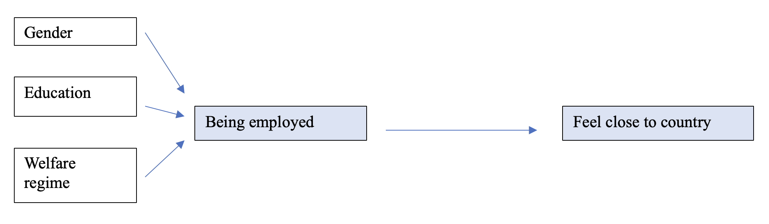

1. **Data and Variables**

**4.1 Data**

For the aim of this research the data used for the analysis was collected by the European social surveys (ESS), Round 7 of 2014. The European Social Survey (ESS) is an academically driven cross-national survey that has been conducted across Europe since its establishment in 2001. Every two years, face-to-face interviews are conducted with newly selected, cross-sectional samples. It collects data concerning different topics, such as attitudes, belief and behavioural patterns in diverse populations across 30 countries.

**4.2 Variables**

In order to conduct the research and answer the research questions the sample selected consists of the immigrant population of the countries featured in the dataset, selecting the ones that had at least 30 cases, making it the unit of analysis. Subsequently the countries taken under consideration, had been grouped together depending on their welfare state model as suggested by Ferrera (2019), Vogliotti and Vattai (2014), which are liberal, social democratic, conservative, mediterranean or south european and the hybrid. For the purpose of this research the aggregation into welfare state models was made to have a better analysis consisting of more cases, so that it could be more statistically relevant. Moreover a distinction was made between citizens and non-citizens, the first not being taken into account, although immigrants with a citizenship might be existing. The variables used related to the employment of the sample, their integration in the host country, their gender and their level of education.

**Independent variable (X)**

Employment status is the explanatory variable, which has been operationally defined as employed and unemployed, re-coding it by merging the two variables into one, making it dichotomous.

**Dependent variable (Y)**

Integration perceived by the immigrants is the outcome variable. In the data set used for the analysis there was not a variable labelled as “integration”, instead there was a variable that measured the closeness felt towards the country (feel close to country), which in this case is used to look at the integraction of the immigrant population.

**Control variables**

In order to strengthen the outcome of the relationship of the model, a series of control variables have been introduced: Gender, Country and Educational Level, creating other models that describe in more detail the relationship between the X and the Y. These are all variables that precede, in a way, the independent variable, being characteristics that are inherent to the sample. The first variable is a dichotomous variable, whereas the others had been categorised in a way that was helpful for the analysis. The second one, as already explained above, through the welfare regime models existing and the third one simply had been recorded to make it easier to analyse.

In the next paragraph it will be shown how, and through which methods, the variables had been re-coded and categorised.

1. **Methods**

Before proceeding using statistical methods to answer our research questions, we initially analyzed the variables we wanted to consider, recoding them in order to create the sample.

We recoded the independent and dependent variables into dichotomous ones. About the dependent variable(feeling close to the country), we considered two categories, since we summed up “Very close” and “Close” into feeling close, while “Not very close” and “Not close at all” into not feeling close: this because of the few cases (that were 41) in the “Not very close” category. About the independent variable, since there were no variables that divided the sample into this categorization, we generated a new one summing up more categories in different variables.

As reported before, our independent and dependent variables are recoded and transformed into dichotomous variables and for this reason we used a multinomial logistic regression. At first, we tested the main relationship between independent and dependent variables through a chi-squared test: thanks to this test we can see if there is a relation between the variables, and thanks to the regression and P-value we see if the relation is significant or not.

Based on the literature review presented above, we decided to control the main relation between X and Y with certain variables, that are: welfare regime of the country, gender, and level of education. We build up four models (explained in Table n.3 in the appendix section of this paper) that start from the first model that considers the main relation, finishing in the final where all the control variables are presented.

1. **Findings**

The following graph shows an initial correlation between the independent variable and independent variable. As it can be seen, immigrant people, whether they are employed or not, based on the sample presented earlier, feel close to the host country they are living in, with just a slight difference in percentages.

**Graph 1** Integration and employment status of the sample

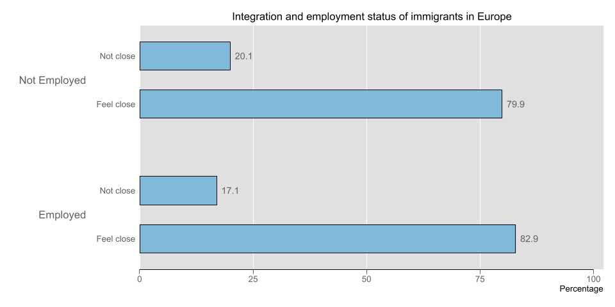(Stata command: catplot fclcntr1 empl_x, percent(empl_x))

**6.1 Logistic regression**

In the case of the main relation between X and Y, the prob > chi2 is equal to 0.1932, and since this value is greater than $ɑ$ = 0.05, this relation is not statistically significant.

Despite this value, to verify the hypothesis we made at the beginning, we control for the other variables that we considered based on the literature(that are welfare regimes, gender and level of education). In all the main relationships considered controlling for these variables, the prob > chi2 values are less than $ɑ$ = 0.05 (precisely 0.000), this means that controlling for them the main relation becomes statistically significant.

About the coefficients, the following graph (Graph 2) shows the intervals of them considering each model (a1, a2, a3, and a4 correspond to the models). These coefficients indicate how the integration changes in each model taking into consideration the independent variable as 1(that in our case corresponds to employee immigrants).

Looking at this graph, we can see that in each model there are always negative coefficient values, but the length is mainly positive. The average of all the models lies within the 0.02 and 0.04 range, while the intervals lie within the -0.02 and 0.08 range. The categories that always show a negative coefficient are: hybrid model as welfare regime, female as gender, and high as level of education. About the second model, this means that living in a nation with a hybrid model regime compared to another nation with a liberal regime negatively influences the integration of the immigrant. Considering the third model, being a female immigrant employee in a hybrid model regime country negatively influences the integration compared to male employee immigrants in a liberal regime country. Finally, taking into account the fourth model, being a female immigrant employee in a hybrid regime country with a high level of education negatively influences the integration compared to male immigrant employees with a low level of education in a liberal regime country.

**Graph 2** Illustration of the coefficient of the different models

(Stata command: coefplot a1 a2 a3 a4, xline(0) keep(empl_x))

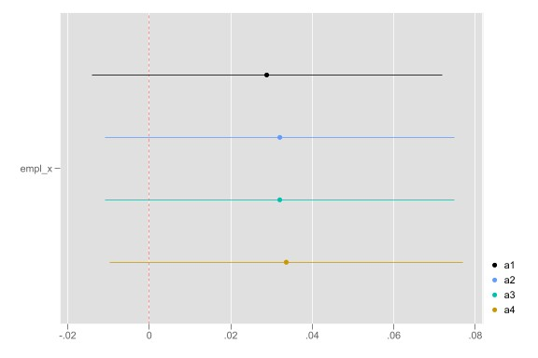

**6.2 Margins**

Model 1 shows that on average, employed, compared with non employed, feel more close to the country by 0.028 (coef.). This reflects our first hypothesis that being employed has a positive effect on feeling integrated into the country.

On model 2 we observe how the relation between being employed and feeling close to the country changes in different nations with different welfare regimes. In particular, we found that the effect on our main explanatory variable increased.

On model 3 we control for gender and it turns out that gender does not have a significant effect on this relationship: it decreases modestly for women by 0.001 (coef.). Even though it is not statistically significant, it is in contrast with the literature that states that women, because they are less likely to find work, are less likely to feel close to the nation.

Considering model number 4 , in which the variables considered are being employed and the perceived level of integration in the country, we can observe that being employed involves a higher sense of integration into the country by .0336 (but the result is not statistically significant).

**Table 1** Margins of all the models

(Stata command: esttab a1 a2 a3 a4)

|  |  |  |  |  |
| --- | --- | --- | --- | --- |
|  | **Model 1** | **Model 2** | **Model 3** | **Model 4** |
| Employment | 0.0288 | 0.0321 | 0.0320 | 0.0336 |
|  | (1.32) | (1.47) | (1.47) | (1.52) |
| Welfare regime | | | | |
| 1.Liberal |  | 0 | 0 | 0 |
|  |  | (.) | (.) | (.) |
| 2.Conservative |  | 0.0246 | 0.0247 | 0.0235 |
|  |  | (0.89) | (0.89) | (0.84) |
| 3.Social democratic |  | 0.0702* | 0.0702* | 0.0704* |
|  |  | (2.20) | (2.20) | (2.23) |
| 4.Mediterranean model |  | 0.0770* | 0.0770* | 0.0747 |
|  |  | (2.02) | (2.02) | (1.93) |
| 5.Hybrid model |  | -0.116** | -0.116** | -0.124** |
|  |  | (-3.20) | (-3.19) | (-3.25) |
| Gender | | | | |
| 1.Male |  |  | 0 | 0 |
|  |  |  | (.) | (.) |
| 2.Female |  |  | -0.00188 | -0.000205 |
|  |  |  | (-0.10) | (-0.01) |
| Level of education | | | | |
| 1.Low education |  |  |  | 0 |
|  |  |  |  | (.) |
| 2.Medium education |  |  |  | 0.00774 |
|  |  |  |  | (0.32) |
| 3.High education |  |  |  | -0.0153 |
|  |  |  |  | (-0.59) |
| ***N*** | 1605 | 1605 | 1605 | 1605 |

If we consider “feel close to the country” in different nations, divided by the welfare regime model, we can see that compared to the liberal model, there is a positive average marginal effect in conservative countries of .02. As for the Social Democratic and Mediterranean models the average marginal effect has a value of 0.07, even in these cases therefore having a job positively affects the feel close to the country.

In the hybrid model, on the other hand, which is more statistically significant, the average marginal effect has a negative value of -.12, so having a job negatively affects feeling close.

Lastly, we control for the educational level and we found that the average marginal effect of those who have a medium level of education positively affects the relationship (0.00774), while the higher level of education has a negative impact (-0.0153).

**Graph 3** Graphical representation of margins considering the fourth model

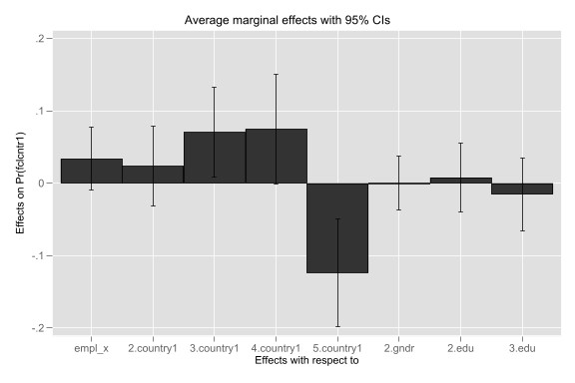(Stata command: marginsplot, recast (bar))

In this margin plot we can graphically see the average marginal effect of x on y, controlling for countries in welfare regimes, gender and level of education. As it is represented in the graph and reported on the table 1.1, controlling for country, the average marginal effect first decreases by 0.0053, then it rises and becomes almost stable with the Social Democratic and Mediterranean model. Then, as we saw before, it drastically decreases again in the Hybrid model, where we have the lower number cases. Then we include in the analysis the control for the second covariate gender (gndr, male=0, female=1), the average marginal effect is almost equal to 0, rising from the previous point. At the end, we insert the covariate of education level (edu, low=0, medium=1, high=2) and from the higher value of medium, it decreases for higher educated.

As we can see, we find the most drastic changement in the effect of x on y the moment we control for the Hybrid model, where we discover a decrease from 0.0747 in the Mediterranean to -0.124. The explanation of these events could be find in the process of integration faced by immigrants in Estonia, the country considered with the Hybrid model. In fact, by reading the “Integration Strategy” planned for the years 2000-2007 and 2008- 2013 by the elected government, we see that one of the key point of the plan consist in the “retention of cultural autonomy” (Jakobson, 2014/21 pp10), with a highly liberal perception over the economic consideration of immigrants. In addition to that, in the article by Jakobson we read that “However, research on individual attitudes has reflected a rather low willingness to accept new immigrants in Estonia” (Jakobson 2014/21 pp9).

Moreover, regarding the negative level of perceived integration by the highly educated migrants, these data could be explained by the literature of Sociology of Migration regarding the “paradox of integration”. With this concept, researchers define the element of education as “an obstacle for developing positive attitudes toward natives and the host society. A key reason for this might be that higher educated immigrants feel relatively deprived” (Verkuyten, 2016). The feeling of “relatively deprived” points out the perception of disadvantages that one minoritarian group has towards a more prominent group.

“*The higher educated are actually experiencing more discrimination and lower acceptance in everyday life. The higher compared with the lower educated more often use host country media and tend to have more negative contacts with majority members on the labor market and in associations, and therefore are more exposed to discrimination and derogating messages*.” (Verkuyten, 2016)

1. **Conclusion**

In this paper the perceived integration of immigrants based on their employment status is investigated, in the context of different European countries. The findings of this paper, regarding the positive influence of the employment status on integration, align with previous research. By enhancing the first model, adding different control variables, the relation between the two variables is explained even further. Moreover, controlling for the average marginal effect, we discovered that in almost all the Welfare Models in which we divided the countries into, the relation between our main x and y is positive, especially, but not surprisingly, in the Social Democratic and Mediterranean Models. The only negative outcome could be found in the Hybrid Model, more precisely in Estonia, in which the political and social background of the country and its immigration policies influenced the perceived integration of migrants. In addition to that, we found out that, controlling for educational level, the integration paradox was tested, because the higher the migrants level of education, the less they will feel integrated or close to the country.

One discovery that left us surprised was the little difference between the values of females and males regarding their perceived closeness to the new country.

Finally, the results obtained greatly surprised us, as the majority of the assumptions we stipulated were not confirmed. First, we identified the little difference between genders in the feeling of closeness to the new nation. In addition to this, we were also surprised by the negative values reported in integration by the more educated immigrants, which led us to discover a new part of the literature in the Sociology of Migration concerning the integration paradox mentioned above.

1. **Limit of the research**

Since we collected our dataset indirectly, through an European research survey, we deleted many cases because of the recording of all the variables considered. We adapted the original variables to our research question, creating a completely new sample that includes 1605 cases. We are aware of the fact that we are not applying statistical techniques on a large sample. This scarcity of cases influenced the recodification of the variables: as reported before, both the dependent and independent variables are dichotomous, but in the case of the integration, consider more categories could have been useful in order to consider separately the different levels of integration of the immigrants and their possibly different influence on the relation.

Finally, our sample doesn't include immigrants from all the European countries, and the number of immigrants are not equally distributed between them. This could be a limit of this research for two reasons: first, we consider as a control variable the welfare regime of the country, second, this variable doesn't include all the countries in Europe that have that specific welfare regime.

1. **Bibliography**

ALBA, R., & FONER, N. 2015. *Strangers No More: Immigration and the Challenges of Integration in North America and Western Europe*. Princeton University Press. <http://www.jstor.org/stable/j.ctt1h4mjf4>

Chiaromonte W, Ferrara M.D. 2022. L’integrazione dei migranti attraverso il lavoro, fra luci e ombre. Riflessioni su regolarizzazione e ruolo del sindacato. in "Rivista del Diritto della Sicurezza Sociale, Rivista trimestrale" (2)2022. pp. 315-336. doi: 10.3241/104462

De los Reyes, P. 2017. Working life inequalities: do we need intersectionality?, Society, Health & Vulnerability, 8:sup1, 1332858, DOI:10.1080/20021518.2017.1332858

Esping-Andersen, G. 1989. *The three worlds of welfare capitalism*. Polity Press.

European Commission. 2019. SUSTAINABLE INCLUSION OF MIGRANTS INTO SOCIETY AND LABOUR MARKET. DOI: 10.2767/42969

European Commission. Directorate-General for Migration and Home Affairs. 2022. New EMN study published: Integration of migrant women, available on [new-emn-study-published-integration-migrant-women-2022-09-07_en](https://home-affairs.ec.europa.eu/news/new-emn-study-published-integration-migrant-women-2022-09-07_en)

Ferrera, M. 2019. *Le politiche sociali*. Il mulino. Bologna.

Gallotti, M., & Mertens, J. 2013. Promoting integration for migrant domestic workers in Europe: A synthesis of Belgium, France, Italy and Spain.

Geddes, A. 2004. Migration and the Welfare State in Europe. <https://doi.org/10.1111/j.1467-923X.2003.00587.x>

Grappi G. 2020. Europe and the Contested Politics of Migration Between Logistification and Global Justice. In Globus Research Papers. (7)2020. DOI:[10.2139/ssrn.3557952](http://dx.doi.org/10.2139/ssrn.3557952)

Grimm, N., Hense, A., & Vogel, B. 2023. How employment generates social integration: trends towards disintegration and over-integration in the hyper-work society. *KZfSS Kölner Zeitschrift für Soziologie und Sozialpsychologie*, 1-26.

Hansen, R. 2012. *The centrality of employment in immigrant integration in Europe*. Migration Policy Institute Europe.

Huddleston, T., Niessen, J., & Tjaden, J. D. 2013. *Using EU indicators of immigrant integration*. Luxembourg: EUR-OP.

Jakobson M-L. 2014/21. Integration Policy Instruments in Estonia. In Research Report Country Report INTERACT RR2014/21 European University Institute Robert Schuman Centre for Advanced Studies. Available on https://hdl.handle.net/1814/33134

Nekby, L. 2002. How long does it take to integrate?: employment convergence of immigrants and natives in Sweden.

OECD.2020. How to strengthen the integration of migrant women? In Migration Policy Debates. (25)2020 available on [migration-policy-debates-25.pdf](https://www.oecd.org/els/mig/migration-policy-debates-25.pdf)

Schmidt, W., & Müller, A. 2021. Workplace universalism and the integration of migrant workers and refugees in Germany. Industrial Relations Journal, 52(2), 145-160.

Sciortino, G., 2004. Immigration in a mediterranean welfare state: the italian experience in comparative prospective. Journal of Comparative Policy Analysis, Vol. 6, No. 2, 111 – 129, August 2004 doi:[10.1080/1387698042000273442](https://doi.org/10.1080/1387698042000273442)

Verkuyten M.2016. The Integration Paradox.” *American Behavioral Scientist* 60 (5–6): 583–596.

1. **Appendix**

**Table 2** Recodification of the variables in Stata

*1. Independent and Dependent variable*

We recoded the dependent and independent variable into dichotomous variables, numbering them using 0 and 1

|  |  |  |  |
| --- | --- | --- | --- |
|  | 0 | 1 | Label variable in Stata |
| Independent variable | Employee | Not employee | empl_x |
| Dependent variable | Feel close to the country | Not feel close to the country | flctcnty1 |

*2. Gender*

|  |  |  |  |
| --- | --- | --- | --- |
|  | 0 | 1 | Label variable in Stata |
| Gender | Male | Female | gndr |

*3. Level of education*

|  |  |  |  |  |
| --- | --- | --- | --- | --- |
|  | 1 | 2 | 3 | Label variable in Stata |
| Level of education | Low | Medium | High | edu |

*4. Welfare regime*

|  |  |  |  |  |  |  |
| --- | --- | --- | --- | --- | --- | --- |
|  | 1 | 2 | 3 | 4 | 5 | Label variable in Stata |
| Welfare regime | Liberal | Conservative | Social democratic | Mediterranean model | Hybrid model | country1 |

**Table 3** Categories considered in each model used

|  |  |  |  |  |  |
| --- | --- | --- | --- | --- | --- |
|  | Employment(X) | Feeling close to the country(Y) | Welfare regime | Gender | Level of education |
| Model 1 |  |  |  |  |  |
| Model 2 |  |  |  |  |  |
| Model 3 |  |  |  |  |  |
| Model 4 |  |  |  |  |  |

**Graph 4** Graphical representation of margins considering the fourth model

(Stata command: margins, dydx(*) post)

